Karan Raj Jayswal

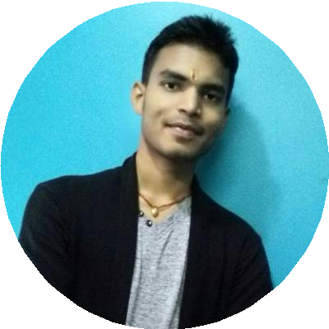

Student

---------------------------About Me-----------------------------

I am Karan Raj Jayswal from Malangwa, Sarlahi

, Nepal. I am hard-working student of computer science in Sardar Vallabhbhai National Institute of Technology,Surat

,Gujarat.

[karanjayswal353@hotmail.com](mailto:karanjayswal353@hotmail.com) 

+91-8789962561 

Malangwa,Sarlahi, Nepal  [github.com/karanjays](https://github.com/karanjays) 

# **EDUCATION**

**Engineering**

Sardar Vallabhbhai National Institute of Technology,Surat ,Gujarat.

*08/2019 – 2023*

**–** 7.85 (3rd sem)

**+2**

HTML/CSS

Python

Javascript

*India*

# **TECHNICAL SKILLS**

C/C++

**CERTIFICATE**

Dayanand Anglo -Vedic Sushil Kedia Vishwa Bharati Higher Secondary School,Jawalakhel, Lalitpur, Nepal

HackerRank(C-intermediate)

@karanjayswal3531

*2016 – 2018*

*Higher Secondary Examination Board*

3.23/4

*Nepal*

HackerRank(C-Basic)

@karanjayswal3531

**SLC**

Apex Academy Lower Secondary Boarding School,Malangwa,Sarlahi,Nepal

# **LANGUAGES**

*2016*

*Nepal Education Board*

3.55/4.0

*Nepal*

Nepali

*\*\*\*\*\**

English

*\*\*\*\**

Hindi

*\*\*\*\*\**

Maithili

*\*\*\*\*\**

**Lower Secondary**

Apex Academy Lower Secondary Boarding School,Malangwa,Sarlahi,Nepal

Hiking

Kabddi

# **HOBBIES**

*2013*

*District Board*

75.29%

*Nepal*

Reading